Instructions – Inserting an Image
ATTENTION: This method is not used for product images. Please see the tutorial for creating a product to find out how to add a product image.
Please try and keep the image sizes as small as possible to reduce the time it takes to load.
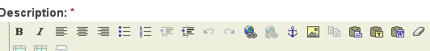

- Find the ‘Image’ button. If you hover over the top, it should say ‘Insert/Edit Image’. Select this button.
- Once selected, you should see a pop up box appear.
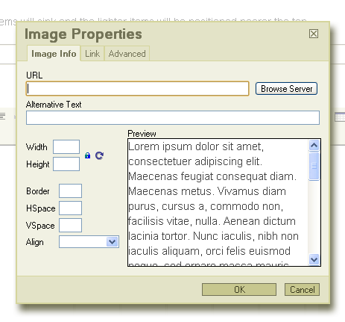
- Select the ‘Browse Server’ button to choose the image you wish to upload.

- Another pop up window should open.
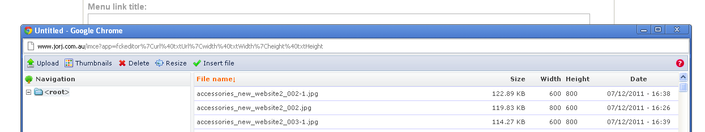
Note: This window will show you every image that has been uploaded on your site before.
- Select the ‘Upload’ button in the top left hand corner. This will bring up another pop up box in the same area.
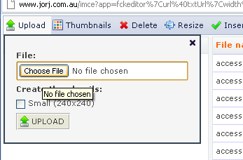
- Select ‘Choose File’ to choose the image you would like to upload. This will bring up another box allowing you to search your computer and/or server for the photo.
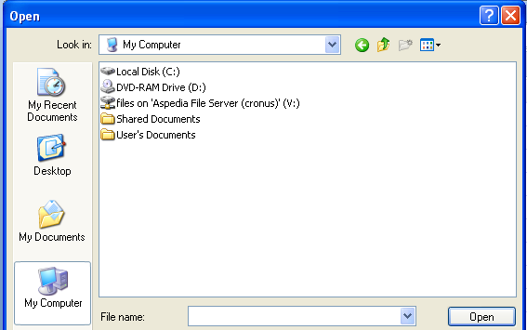
- Once you have found the file, select it then click ‘Open’. The pop up window will disappear and you’ll return to the previous pop up box with the file you selected.
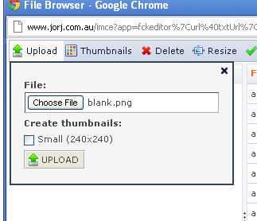
Note: If ‘Small’ isn’t selected, the image may be too big and can mess up text. To be safe, always select ‘Small’. It’ll produce two copies of the image; one small and the other it’s normal size. You can compare the sizes in the pop-up menu before selecting which one to use. It is recommended that you select small unless the image size is already small.

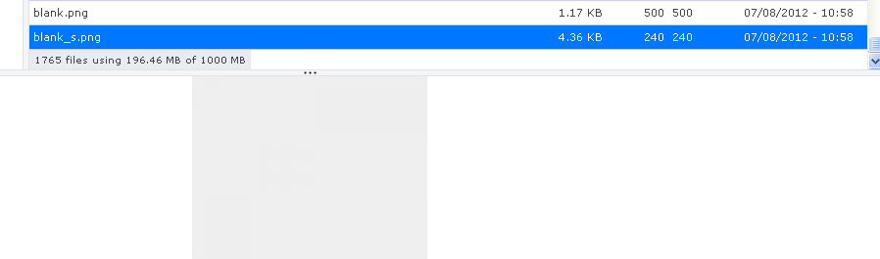
Image preview area

- You will then see your image appear in the list of other images. If you selected ‘Small’, there will be another version of the image with ‘_s’ on the end of the name. This image is the smaller version of the original image. Your image will also preview in the space below the list of images.
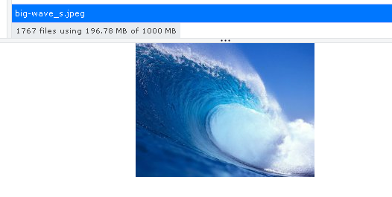
Image preview area
- Once you have selected the image and size, double click on the image name and that pop up box will close. Now in the first pop up box you will see the image path, and a preview of what it’ll look like with the rest of the content in the description area.
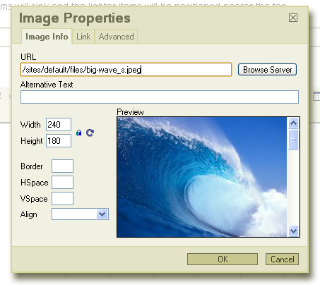

Note: The preview area will show the picture and position of text. The text shown is an automatic default example, meaning it will not show the actual text you have typed. If you see something along the lines of:
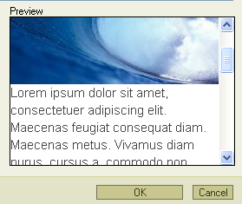
Then it is completely normal. This is the default preview setting we have created. Your content will replace the default text. DO NOT STRESS ☺

- As well as giving you a preview, this pop up box allows you to change the position on your text in regards to the image. You can move the image to the side and place the text around it, move it in to the middle and so on.
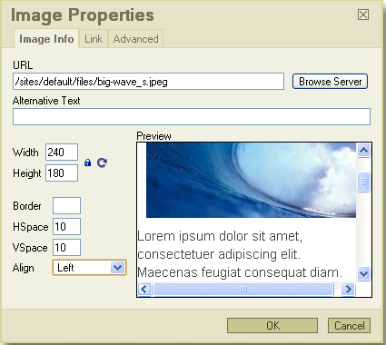
Align: Allows you to change the position of the picture. The preview will update every time this is changed so if you’re unsure where the picture will end up and how the text will look, the preview will show you. You must select an alignment or there will be big spaces between the text and image.
Border: Allows you to add a border to the image. The size is in pixels. It is recommended that you use ‘10’ if you’re inserting a border.
Width & Height: You can customise the size of the image here by entering in a number (in pixels). We do not recommend changing this as pixilation or image degradation can occur.
What does HSpace and VSpace mean?
This determines how much space is around the image both, horizontally and vertically (hence H and V). The recommended value for this area is ‘5’. If no number is entered, the content will not wrap around the image (looks messy)
What about Alternative Text?
This helps Google to decide when to show this image.
An example for the image above:
It’s a picture of a wave so we could make the alternative text ’Wave’, any user who searched ‘Wave’ in images will stumble upon this picture.
Once your settings have been adjusted, click ‘Ok’.
ATTENTION! The image is inserted where ever the cursor is in the body area.
Once you have made all desired changes, scroll down to the bottom of the page and select ‘Save’. Your content should now be saved and you should refresh the edited page to see the changes.
Alternatively, before saving you can ‘Preview’ what the page is estimated to look like.
ATTENTION: Remember to save your page once you have made your changes by clicking on the ‘Save’ button at the bottom for the page!!
If you need to edit the image properties after you’ve inserted it, highlight the image, right click and you should see ‘Image properties’ as an option. Select that and the pop up box should appear again.

